How to Get the Most Out of Your Brain
Senior Project
In partial fulfillment of the requirements for
The Esther G. Maynor Honors College
University of North Carolina at Pembroke
By
Keely Jones Aliseo
UNCP School of Nursing
October 24, 2022

Keely Jones Aliseo 24 OCT 2022
Honors College Scholar

Mrs. Martha Hepler 24 OCT 2022
Faculty Mentor
Acknowledgements
I would like to thank Mrs. Hepler for being dedicated to my success in this project. I thank the Maynor’s Honors College for allowing us to be creative in our thinking and choose a topic of passion.

Abstract
This papers intent is to inform the reader of how to utilize their brain to it’s maximum capacity. We will explore the topic of nutrition, exercise, music and brain games to examine how each of these can enhance our brain function. The Mediterranean diet provides adequate brain nutrition. Physical exercise promotes blood flow to the brain. Music and brain games utilize brain lobes to play an instrument, sing or solve problems presented in games such as chess.
Key words: brain, nutrition, exercise, music

How to Get the Most Out of Your Brain
In a world that is ever evolving, we need to utilize the maximum potential of our brain. The three major parts of the brain include the cerebellum, brainstem, and the cerebrum. The largest part of the brain, the cerebrum, is divided into two hemispheres and plays a major role in many bodily functions. Each cerebral hemisphere consists of four lobes - the frontal, temporal, occipital, and parietal – each having their own unique functions. A visual summary of various parts of the brain and their functions is provided in Appendix A. Johns Hopkins Medicine (2022a) summarizes the major functions of these lobes in the following way:
- Frontal lobe: personality, decision-making, reasoning, movement, smell, and speech
- Parietal lobe: spatial relationships, interpretation of pain and touch, understanding of spoken language, and calculation
- Occipital lobe: visual processing
- Temporal lobe: short-term memory, music, object recognition, and understanding language
Deeper within the brain lies the hippocampus which plays a major role in memory and learning. All forementioned structures and functions play a critical role in one’s cognition, which is defined as “the mental action or process of acquiring knowledge and understanding through thought, experience and the senses” (Cambridge Cognition, 2015).
Dr. Robert Poage (personal communication, June 20, 2022), Professor and RISE Co-Director at the University of North Carolina at Pembroke, specializes in neurology and was asked about the most important structure in the brain for thinking. He states:
Higher order thinking skills (complex data analysis, planning future actions, prediction of potential outcomes), is processed primarily in the thin exterior-most shell of the brain called the cerebral cortex. Different areas of cortex can have very different, specialized functions. These functions can change over time, not only through learning, but also if an area of cortex is damaged, another region may be able to pick up the workload of the damaged area.
Dr. Poage continued by addressing factors impacting brain function and described the brain as
“an extremely ‘plastic’ organ meaning that it is constantly modifying connections between neurons in order to more effectively respond to what is going on outside the brain”.
Though not all-inclusive, this paper will elaborate on specific factors outside the brain that impact overall brain function. Discussions will focus on exercise, diet, hobbies, and brain games. Lastly, considerations for practical applications to life will be provided along with suggestions for incorporating them into daily routines.
Exercise
Exercise has been shown by numerous studies to be a key factor in human longevity. In animals, research shows that exercise increases neuronal and axonal density. Brain-derived neurotrophic factor (BDNF), which maintains the health of neurons and promotes the growth of new ones, and its receptor tropomyosin-related kinase B is enhanced by early exercise, specifically in the forming of the hippocampus which is involved in emotional processes, mnemonics, and is critical for learning and memory. The ability to recall memories in later life is aided by exercise. Fotuhi (2015) states that exercise is the best way to generate new neurons in the hippocampus which is larger in those who exercise regularly versus those who do not. Serra et al. (2019) support this assertion by finding adolescent rats that were physically active to have a higher quantity of neuronal cells in the hippocampus and cerebral cortex than those that were inactive. Even when these rats were briefly sedentary, their levels of neuronal cells remained higher. Dendritic arborization, the pattern of dendritic branching which help regulate electrical properties of neurons, was greater in physically active rats compared to the control leading to the conclusion that early exercise contributes to a complex neural circuitry which can aid the brain in tolerating brain damage and increasing academic functioning (Serra et al.; Urbanska et al., 2008). Harvard Medical School (2020) reports many of the same findings and adds exercise:
- Promotes oxygenated blood to be delivered to brain cells, promoting growth of blood vessels to a variety of brain regions.
- Preserves volume in regions of the brain that tend to shrink with age.
- Maintains the integrity of white matter in the brain.
- Promotes sleep.
- Helps sustain mood.
Dr. Robert Poage (personal communication, June 20, 2022) further explains that “exercise in particular has been shown to modify areas of the brain involved in mood, motivation, spatial memory, and feelings of satisfaction. Exercise is one of the few treatments that is currently shown to slow the progression of neurodegenerative diseases”.
The practical application that can be deduced from the above research is to get moving. Start off slow, get active 2 days a week and work your way up to 5 days. The Physical Activity Guidelines for Americans recommends for adults to get 150 – 300 minutes of moderate-intensity aerobic exercise per week (or 75 - 150 minutes of vigorous-intensity aerobic exercise) and to complete muscle-strengthening activities of moderate or greater intensity on 2 or more days a week (U.S. Department of Health and Human Services (USDHHS], 2018). Harvard Medical School (2020) encourages the addition of strength training to “improve brain plasticity, attention, and associative memory” (p. 28). They suggest engaging in two 30-minute sessions each week allowing 2 days between each session for muscle recovery. I have found in my own schedule that going in the morning before I begin my work/school day is best for me. Your sleep schedule will adjust in a few weeks of you beginning this process. Going for a 3-mile jog takes approximately 30 minutes for the average human and is a great place to start your fitness journey (Roven, 2022).
Diet
The impact of diet on overall health is well-documented in the literature. Imbalanced nutrition, whether taking in too much or too little of specific nutrients, has been linked to a variety of physiological disorders including decreased cognitive functioning and mood disorders. In particular, the connection between cognitive functioning and intake of homocysteine, folate, B vitamins, omega-3 fatty acids, and the Western diet will be discussed.
The Agricultural Research Organization (2007) conducted experiments to understand the role of homocysteine on cognitive function. Lab mice were fed one of two diet options. In the first option, the diet was focused on folate. Mice with high levels of homocysteine had low levels of folate. Folate is considered essential for healthy cognition and emotional health, and adequate folate levels can help lower homocysteine levels, an amino acid linked to cardiac disease and dementia (Harvard Medical School, 2020). A folate deficiency can lead to megaloblastic anemia, characterized by abnormally large red blood cells, which can impact cognitive functioning by causing weakness, fatigue, difficulty concentrating, and irritability (UDHHS, 2021). They recommend for pregnant women to consume 600 mg of folic acid a day to prevent birth defects and neurodevelopment impairments such as autism-like disorders. In summary, the negative effects of low folate and high levels of homocysteine are correlated with an increased risk of having a stroke, heart disease, Alzheimer’s Disease, and dementia.
The second diet focused on the intake of B vitamins. Vitamins B6 and B12 are essential for normal brain function. Low vitamin B12 levels were directly related to lower cognitive function test scores than those with normal vitamin B12 levels (Bliss, 2007). In addition, deficits in vitamins B6 and B12 have been linked to increased homocysteine levels which, as mentioned previously, increases the risk of dementia (Harvard Medical School, 2020).
According to Harvard Medical School (2020) and the National Institutes of Health (NIH, 2018), a specific omega-3 fatty acid, docosahexaenoic acid (DHA), is an essential component of brain cells. They report deficient omega-3 levels have been observed in those with cognitive decline, Alzheimer’s disease, and dementia. Diets high in omega-3 fatty acids may be protective of cognitive health due to the role omega-3 fatty acids play to “maintain neuronal function and cell-membrane integrity within the brain” (NIH, section 7). Omega-3 fatty acids have been shown to improve the anti-inflammatory response in long-term inflammation which could impact the blood-brain barrier (Aridi et al., 2017). Harvard Medical School suggests these properties may enhance memory and mental performance while slowing the progression of depression and cardiovascular disease.
The Dietary Guidelines for Americans 2020-2025 defines a healthy diet as one that “consists of nutrient-dense forms of foods and beverages across all food groups, in recommended amounts, and within calorie limits” (U.S. Department of Agriculture and U.S. Department of Health and Human Services [USDA/USDHHS], 2020, p. ix). They further recommend that foods/beverages high in saturated fat and added sugars be limited with each providing less than 10% of daily calories. However, the typical Western diet is high in saturated fats and added sugars, both of which have been shown to have a negative impact on overall health. One mechanism especially impacting cognitive function involves an area of the brain known as the hippocampus which helps control certain learning and memory processes. The Western diet also has a negative impact on the gut microbiome which consists of an estimated 100 trillion microbes residing in the gastrointestinal tract. This system produces a variety of mediators which enter the circulation and communicate with multiple organs throughout the body, including the brain, and plays a vital role in normal metabolism and prevention of disease (Sidhu & Poorten, 2017). Cognition is impacted in a variety of ways due to a decreased level of some microbes with elevated levels of others. The Western diet is also associated with increased neuroinflammatory markers which have been linked to impaired cognition and increased inflammation in the hippocampus and cortex (Nobles et al., 2017). Lastly, consuming foods high in saturated fat increase the risk of cardiovascular disease and stroke which could have devastating sequel for brain functioning. Harvard Medical School (2020) reports that “eating more saturated fat led to a 39% higher risk for Alzheimer’s and more than doubled the risk for dementia in general” (p. 25).
A practical application related to the above research is to evaluate your diet and adjust it as needed to promote optimal health and brain functioning. Keeping a food journal for a week will help identify types of foods typically consumed. Evaluating the vitamins and other nutrients provided by, or lacking in, these foods will assist in the identification of nutritional deficits and excesses. The Dietary Guidelines for Americans 2020 - 2025 recommends a healthy dietary pattern to promote health and cognitive function and describes this as a diet as including a variety of fruits and vegetables, a variety of grains with at least ½ being whole grains, fat-free or low-fat dairy products and oils, and a variety of protein foods such as lean meats, poultry, eggs, seafood, lentils, nuts, and soy. They also recommend limiting foods and beverages that are high in sugar, saturated fat, sodium, and alcohol as well as staying within daily caloric intake recommendations (USDA/USDHHS, 2020).
Adequate intake of folate, vitamin B6, and vitamin B12 should also be included in the typical diet. Clams, sardines, salmon, beef, fortified food (cereal, flour, pasta, rice, other grains), and dairy products are examples of foods high in vitamin B12 and folate. Many fruits and vegetables, peas, beans, nuts, and eggs also provide folate (USDHHS, 2021). Including at least one of these foods in the diet per day is encouraged.
Following a plant-based diet instead of the typical Western diet has been linked to lower cholesterol and reduced incidence of heart disease, various cancers, and Parkinson’s Disease. Harvard Medical School (2020) encourages a plant-based diet, such as the Mediterranean diet, to improve cognitive functioning and decrease the risk of cognitive impairment and/or dementia. Aridi et al. (2017) supports this recommendation for a variety of reasons saying it provides a large source of antioxidants which has been linked to decreased risk of cognitive decline, it encourages a high intake of fish and olive oil which are both rich in omega-3 fatty acids, and it decreases the risk of cardiovascular disease which is a risk factor for dementia. The Mediterranean Diet Pyramid summarizes recommendations for this diet (See Appendix B).
Harvard Medical School recommends the following tips to establish a Mediterranean-type eating plan:
- Eat fatty fish at least twice a week (salmon, pollack, catfish, tuna).
- Cook with unsaturated fats such as olive oil rather than saturated fats.
- Eat a variety of colorful fruits and vegetables for antioxidant benefits.
- Consume leafy greens (kale, collards, spinach) which provide a variety of nutrients for the brain, including folate, which might help slow cognitive decline.
- Consume 100% whole grains such as barley, rye, and oats, rather than refined grains.
- Consume nuts, such as walnuts and almonds, which are high in an omega-3 fatty acids and have high antioxidant and anti-inflammatory actions.
- Eat fruits for dessert. Berries, especially blueberries, are high in antioxidants and have been shown to improve memory.
There are a variety of food tracking apps that make this quite simple. Lose it (FitNow, Inc., 2022), Calorie Counter (Renteria, 2022), and MyPlate Calorie Counter (Leaf Group, Ltd., 2022) are a few of the dozens of food trackers available for free. These Apps are compatible with iOS and Android and can also be accessed online.
Hobbies
Johns Hopkins Medicine (2022b) states, “If you want to firm up your body, head to the gym. If you want to exercise your brain, listen to music” (para. 1). Musical instruments have been shown to provide neurorehabilitation abilities and playing the piano has been shown to activate both cerebral hemispheres (Mielnik & Mielnik- Matityuha, 2013). Playing instruments, singing, and listening to music have all been shown to assist clients during recovery after having a stroke. While listening to music, the right temporal lobe is activated. The left motor and premotor cortex, which are in the frontal lobes, are activated when we speak or sing (Mielnik & Mielnik- Matityahu). Reinforcing what Dr. Poage stated during his interview, neuroplasticity, or brain plasticity, involves the brain’s ability to change over time by making new connections between neurons. Michelon (2008) discusses these plastic changes as being increased in professional musicians compared to non-musicians and involve multiple areas of the brain including the motor, parietal, and temporal areas.
These outcomes were illustrated in two case studies involving clients after a having a stroke (Mielnik & Mielnik-Matityahu, 2013). Both had previously studied music and played an instrument, and one client also sang in the choir. The affected joint in the hand was able to be coerced into performing the desired function that the other hand was doing while playing the instrument. Client A had difficulty with pronunciation following her stroke, and when she began singing as a corrective measure, her pronunciation improved dramatically. These researchers vouche that all schools should teach a piano class and that music courses should be offered year-round (Mielnik & Mielnik-Matityahu).
A practical application for the above research linking the effects of music to cognitive function would be to research different instruments and select one you would like to learn how to play. I personally did this, and I chose the keyboard. I ordered a basic keyboard from Amazon for less than $100 and downloaded an app called SimplyPiano (JoyTunes, 2022), an online piano course aimed towards various levels of piano players. Many instruments are inexpensive and may even be found at thrift shops. Beginner instrument books and apps can be found online or in music stores. I have played approximately 60 minutes per week for the past 6 months. A difference I noticed in my learning habits is that I have become a more efficient auditory learner. It is also something I find extremely relaxing.
Brain Games
Brain games have been discussed in the literature for years in relation to their impact on cognition, and there is plenty of research to support these games can indeed enhance memory, attention, logic, and other cognitive functions (Al-Thaquib et al., 2018). Games such as Sudoku, Lumosity, crosswords, and chess are just a few examples of brain games found in the literature. This discussion will focus on the impact chess has been shown to have on cognitive function.
Nichelli et al. (1994) studied the brain using water positron emission tomography (PET) while playing chess. It was found that different actions in the game of chess activated different parts of the brain. The rule of retrieval activated the left hippocampus responsible for short and long-term memory in addition to consolidation of information. Chess move sequences activated the temporal lobe and hippocampus. The temporal lobe is responsible for processing sensory information and is utilized for comprehension and the association of emotions with sensory input. The occipital, parietal, and frontal lobes were activated in the action of checkmate. The occipital lobe helps us to process visual stimulation. The parietal lobe comprehends sensory input from the rest of our body. The frontal lobe is the essence of our character traits and our ability to express emotions and words. Additionally, there was activation of the left orbital frontal cortex and the right prefrontal cortex. Researchers believe these regions are involved in the planning and execution of check mate strategies (Nichelli et al.). Fattahi et al. (2015) compared auditory memory in chess players versus those who did not play chess and found their auditory memory to be significantly superior to those who did not play chess.
Practically put, chess is an excellent brain stimulant. Chess is offered free at many restaurants, libraries, and other facilities. If you are like myself and have no prior experience playing, I recommend downloading a free app called Chess (cnvcs, 2016). It provides video tutorials ranging from the basics of chess all the way through advanced playing strategies. The Chess app has varying levels of competition for all its users. A reasonable way to input chess into your daily schedule is to play for 5 minutes a day while waiting for the bus, for class to start, the meeting to begin, or your food to be done at your favorite lunch location.
Conclusion
The brain is an ever-growing and changing organ. There are many things we do, or do not do, that can have a positive or negative impact on its ability to function to the highest extent possible. When asked for practical tips to enhance brain functioning, Dr. Poage (personal communication, June 20, 2022) summarized the many of the key factors discussed in the following statement:
The brain is like a lot of other organs in that it needs a regular, healthy blood supply to function effectively. For that reason, doing things that increase cardiovascular health (eating healthy, maintaining a healthy BMI, exercising regularly) will also increase brain health and optimize brain function. Performing difficult tasks (reading, maybe the brain games you mentioned) will also lead to the generation of new circuitry in the brain that will increase the number and type of information processing circuits in the brain. Watching TV or playing simple video games fails to provide novel stimuli to the brain, and simply reactivates existing circuits (personal communication).
Dr. Poege goes on to say:
If you don't try to do new things with your brain on a regular basis, your brain will be unlikely to produce unique, interesting patterns of activity that can generate solutions to problems that we have never seen before. Having a teacher or a supervisor who allows you to try out your own ideas – even if they may fail - could be real valuable in generating more confident people who are willing to try something, even if it fails, which is the only way new ideas and products are generated (personal communication).
In conclusion, challenge yourself daily. The best thing to do to keep your brain functioning and stimulated is to change up your routine. Add exercise, a good healthy diet, different types of music, and challenging games to your weekly routine. Never stop learning, and you will be well on your way to being a smarter, healthier you.

References
Al-Thaqib, A., Al-Sultan, F., Al-Zahrani, A., Al-Kahtani, F., Al-Regaiey, K., Iqbal, M., &
Bashir, S. (2018). Brain training games enhance cognitive function in healthy
subjects. Medical Science Monitor Basic Research, 24, 63–69.
https://doi.org/10.12659/msmbr.909022
Aridi, Y. S., Walker, J. L., & Wright, O. (2017). The association between the Mediterranean
dietary pattern and cognitive health: A systematic review. Nutrients, 9(7), 674.
https://doi.org/10.3390/nu9070674
Barrow Neurological Institute (2015). Stroke educational manual. Anatomy of the Brain.
https://www.barrowneuro.org/resource/stroke-education-manual/
Bliss, R. M. (2007). Boosting our knowledge of brain food. Agricultural Research, 55(10), 14
16. https://login.proxy181.nclive.org/login?url=https://www.proquest.com/scholarly
journals/boosting-our-knowledge-brain-food/docview/208053705/se-2
Cambridge Cognition (2015, August 15). What Is Cognition & Cognitive Behaviour - Cambridge Cognition | Cambridge Cognition. (2015, August 19). https://www.cambridge
cognition.com/blog/entry/what-is-cognition
cnvcs (2016). Chess – free. (1.3.0) [Mobile app]. App store.
https://apps.apple.com/us/app/chess-free/id541067628
Fattahi, F., Geshani, A., Jafari, Z., Jalaie, S., & Salman Mahini, M. (2015). Auditory memory
function in expert chess players. Medical journal of the Islamic Republic of Iran, 29, 275. https://www.ncbi.nlm.nih.gov/pmc/articles/PMC4715404/
Firth, J., Gangwisch, J. E., Borisini, A., Wootton, R. E., & Mayer, E. A. (2020). Food and mood:
How do diet and nutrition affect mental wellbeing?. BMJ (Clinical research ed.), 369,
m2382. https://doi.org/10.1136/bmj.m2382
FitNow, Inc. (2022). Lose it! (14.5.700) [Mobile app]. App Store.
https://apps.apple.com/us/app/lose-it-calorie-counter/id297368629
Fotuhi, M. (2015, November 4). Can you grow your hippocampus? Yes. Here’s how, and why it
matters. Sharp Brains. https://sharpbrains.com/blog/2015/11/04/can-you-grow-your-hippocampus-yes-heres-how-and-why-it-matters
Fundación Dieta Mediterránea (2014). The Mediterranean Diet.
http://www.mediterradiet.org/nutrition/mediterranean_diet_pyramid
Harvard Medical School (2020). A guide to cognitive fitness: 6 Steps to optimizing brain function
and improving brain health. Harvard Health Publishing.
https://www.health.harvard.edu/mind-and-mood/a-guide-to-cognitive-fitness
Hollmann, W., & Struder, H. K. (1996). Exercise, physical activity, nutrition, and the brain. Nutrition Reviews, 54(4), 7. https://login.proxy181.nclive.org/login?url=https://www.proquest.com/scholarly-journals/exercise-physical-activity-nutrition-brain/docview/212303498/se-2?accountid=13153
Jatoi, S., Hafeez, A., Riaz, S. U., Ali, A., Ghauri, M. I., & Zehra, M. (2020). Low vitamin B12 levels: An underestimated cause of minimal cognitive impairment and dementia. Cureus, 12(2), e6976. https://doi.org/10.7759/cureus.6976
Johns Hopkins Medicine (2022a). Brain anatomy and how the brain works. Health. https://www.hopkinsmedicine.org/health/conditions-and-diseases/anatomy-of-the-brain
Johns Hopkins Medicine (2022b). Keep your brain young with music. Health.
https://www.hopkinsmedicine.org/health/wellness-and-prevention/keep-your-brain-young-with-music
JoyTunes (2022). Simply piano: Learn piano fast. (9.1.12) [Mobile app].
https://apps.apple.com/us/app/simply-piano-learn-piano-fast/id1019442026
Leaf Group, Ltd. (2022). MyPlate Calorie Counter. (5.42.0) [Mobile app]. App Store.
https://apps.apple.com/us/app/myplate-calorie-counter/id502317923
Michelon, P. (2008, February 26). Brain plasticity: How learning changes your brain. Sharp
Brains. https://sharpbrains.com/blog/2008/02/26/brain-plasticity-how-learning-changes-your-brain
Mielnik, M., & Mielnik-Matityahu, J. (2013). The effect of skills acquired during musical
training on brain functions and the course of neurorehabilitation. Acta
Neuropsychological, 11(1), 47–51.
https://login.proxy181.nclive.org/login?url=https://search.ebscohost.com/login.aspx?direct=true&db=asn&AN=111009147&site=ehost-live
National Institutes of Health (2022, July 18). Omega-3 fatty acids. Office of Dietary
Supplements. https://ods.od.nih.gov/factsheets/Omega3FattyAcids-HealthProfessional/#alzheimer
Nichelli, P., Grafman J., Pietrini, P., Always, D., Carton, J., & Miletich, R. (1994). Brain activity
in chess playing. Nature, 369(6477), 191. doi:http://dx.doi.org/10.1038/369191a0
Noble, E. E., Hsu, T. M., & Kanoski, S. E. (2017). Gut to brain dysbiosis: Mechanisms linking
Western diet consumption, the microbiome, and cognitive impairment. Frontiers in
Behavioral Neuroscience, 11, 9. https://doi.org/10.3389/fnbeh.2017.00009
Nutrition and brain function: Boosting our knowledge of brain food. (2007, November 1). US
Fed News Service, Including US State News. https://login.proxy181.nclive.org/
login?url=https://www.proquest.com/newspapers/nutriton-brain-function-boosting-our-
knowledge/docview/470944679/se-2
Renteria, D. (2022). Calorie Counter. [Mobile app]. App Store.https://apps.apple.com/
us/app/calorie-counter/id1614877833
Roven, A. (2022, September 25). Average time to run 3 miles: Good and bad results explained.
WISDOM RUNNING. https://wisdomrunning.com/how-long-does-it-take-to-run-3-miles/
Serra, F. T., Carvalho, A. D., Araujo, B. H. S., Torres, L. B., Cardoso, F. dos S., Henrique, J. S.,
Placencia, E. V. D., Lent, R., Gomez-Pinilla, F., Arida, R. M., & Gomes da Silva, S.
(2019, September 23). Early exercise induces long-lasting morphological changes in
cortical and hippocampal neurons throughout of a sedentary period of rats. Scientific
Reports, 9(1), N.PAG. https://doi-org.proxy181.nclive.org/10.1038/s41598-019-50218-9
Sharma, S. R. & Silbersweig, D. (2018). Setting the stage: Neurobiological effects of music on
the brain. Crossroads of Music and Medicine. 6. https://remix.berklee.edu/mh-exchange
music-medicine/6
Sidhu, M. & van der Poorten, D. (2017). The gut microbiome. Australian Family Physician.
46(4), 206-211. The-gut-microbiome.aspx (racgp.org.au)
Urbanska, M., Blazejczyk, M., & Jaworski, J. (2008). Molecular basis of dendritic arborization. Acta neurobiologiae experimentalis, 68(2), 264–288.
U.S. Department of Agriculture and U.S. Department of Health and Human Services. (2020,
December). Dietary Guidelines for Americans, 2020-2025. (9th ed.)
DietaryGuidelines.gov
U.S. Department of Health and Human Services (2021, March). Folate. National Institutes of
Health Office of Dietary Supplements. https://ods.od.nih.gov/factsheets/Folate-HealthProfessional/#h7
U.S. Department of Health and Human Services (2018). Physical Activity Guidelines for
Americans, (2nd ed.). https://health.gov/sites/default/files/201909/Physical_Activity_
Guidelines_2nd_edition.pdf

Appendix A
The Brain and its Functions
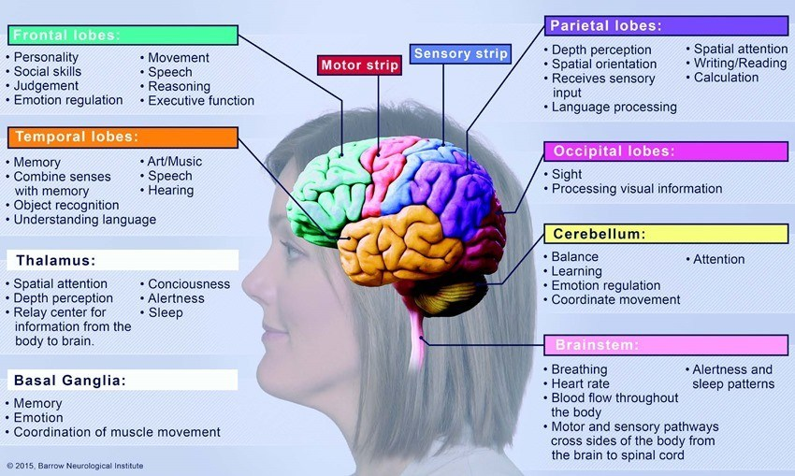
Source: Barrow Neurological Institute, 2015

Appendix B
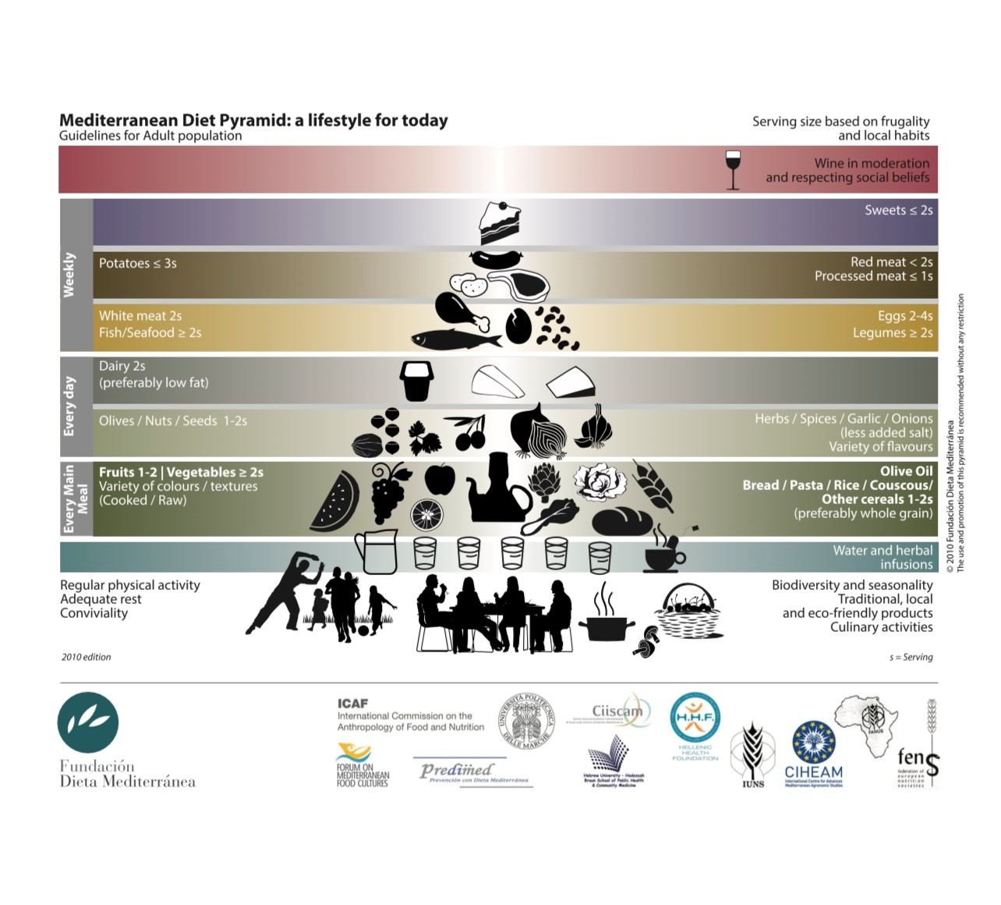Source: Fundación Dieta Mediterránea (2014)

